Music Playlist & Listening Stats Manager

1.Abstract:
This document presents MusicPlaylistManager, a comprehensive, console-based Java application designed to manage music playlists, monitor user listening patterns, and export analytical session data. The system demonstrates core Object-Oriented Programming (OOP) principles—including abstract classes, inheritance, encapsulation, constructor chaining, and method overriding—alongside advanced Java features such as custom exceptions, two-dimensional arrays, collections, and Java Streams and Lambdas.
Key functionalities include dynamic playlist viewing, song play logging with validation via custom exceptions, weekly listening matrix tracking, and popularity-based sorting. Additionally, the software incorporates robust error handling and file I/O operations to persist session statistics locally, showcasing a well-structured architectural model for modular software design in Java.
2.Project Objectives:
Demonstrate Core OOP Principles: Implement modular software design using abstraction (AudioItem), inheritance (Song extending AudioItem), encapsulation (private/protected fields with getters/setters), polymorphism (method overriding), and constructor chaining.Utilize Advanced Data Structures: Manage playlists efficiently using Java Collections (ArrayList) and model multi-dimensional data (songs mapped across days of the week) using a 2D array listening matrix.
Leverage Modern Java Features: Apply functional programming concepts, including Java Streams, Lambda expressions, and custom comparators for data sorting and popularity analysis.I
Implement Robust Error Handling: Ensure system stability by handling standard exceptions (InputMismatchException, IOException) and creating a custom exception (InvalidSongException) for domain-specific validation.
Enable Data Persistence: Provide file I/O capabilities (FileWriter and PrintWriter) to export and save playlist statistics locally to a text file.
Provide an Interactive User Interface: Deliver a menu-driven, console-based user experience for seamless navigation, playlist viewing, and real-time play-count logging.

3.Advantages & Disadvantages:
Advantages:
- Strong OOP Foundation: Demonstrates clean implementation of core Object-Oriented principles, including abstraction (AudioItem), inheritance (Song), polymorphism, and encapsulation.
- Diverse Feature Set: Effectively combines multiple programming concepts into a single project, such as Java Collections (ArrayList), 2D arrays, custom exceptions, and Java Streams/Lambdas.
- Robust Error Handling: Implements try-catch blocks and a custom exception (InvalidSongException) to gracefully handle invalid user inputs (like non-integers or out-of-range IDs) without crashing the application.
- Data Persistence: Features basic File I/O (PrintWriter and FileWriter) to export and save playlist session statistics locally.
- Educational Value: Serves as an excellent template or capstone project for students learning intermediate Java programming, combining data structures, algorithms, and file handling.

Disadvantages:
- Console-Based Interface: Lacks a modern Graphical User Interface (GUI) or web interface, making it restricted to a command-line environment.
- Hardcoded Matrix Constraints: The listening matrix has a fixed size of 5 rows and 7 columns (new int[5][7]). If you add more than 5 songs or more days, it will cause index out-of-bounds errors unless dynamically resized.
- One-Way File Persistence: While it exports data to a text file (playlist_stats.txt), it does not load data back from a file upon startup. All initial data is hardcoded via initializeData().
- Lack of a Real Database: Data is stored purely in volatile memory (ArrayList) during runtime, meaning any updates made during a session (like new play counts) are lost after closing the program unless exported.
4.Implementation Details:
Programming Tools Used:
- Java Development Kit (JDK): For compiling and executing Java code (runs on JVM).
- Integrated Development Environment (IDE) / Code Editor: Tools like IntelliJ IDEA, Eclipse, VS Code, or a standard terminal/command prompt used to write, compile, and run the Java source file.
- Java Standard Library APIs:
  - java.util.* (ArrayList, Scanner, Collections, List)
  - java.util.stream.Collectors (For functional stream operations)
  - java.io.* (FileWriter, PrintWriter, IOException)

Java Concepts Used:
Object-Oriented Programming (OOP): Uses abstraction (AudioItem), inheritance (Song), encapsulation (private/protected fields with getters/setters), polymorphism (method overriding), and constructor chaining (this / super).
Data Structures: Implements Java Collections (ArrayList) for dynamic playlist management, alongside 1D and 2D arrays (int[5][7]) for tracking listening statistics.
Advanced Java (Streams & Lambdas): Employs the Java Streams API and lambda expressions for functional sorting, comparison, and popularity analysis.
Control Flow & Operators: Powered by iterative loops (while, for, for-each), conditional branching (switch-case, if-else), and standard arithmetic/relational operators.
Exception Handling: Combines standard try-catch blocks for runtime errors (InputMismatchException) with a custom exception (InvalidSongException) for domain-specific validation.
File I/O: Uses FileWriter and PrintWriter within a try-with-resources block to export and save session statistics locally.
Main Modules:
Core Domain & OOP Module: Defines the data models (AudioItem and Song) implementing inheritance, encapsulation, and overriding.
User Interface & Navigation Module: Powers the console-based menu loop using Scanner and switch-case branching.
Playlist & Play Tracking Module: Manages the active song collection (ArrayList) and handles dynamic play-count increments.
Analytics & Statistics Module: Manages the 2D listening matrix (int[5][7]) and uses Java Streams/Lambdas for popularity ranking.
Exception Handling Module: Catches runtime user errors and validates input IDs using standard and custom exceptions.
Data Persistence Module: Exports and saves session statistics to a local text file using File I/O.

5.Java code:
import java.io.*;
import java.util.*;
import java.util.stream.Collectors;

// ==========================================
// CONCEPT: OOPs (Abstraction & Inheritance)
// Abstract class defines a base template for audio items
// ==========================================
abstract class AudioItem {
// CONCEPT: Datatypes (String) & Encapsulation (protected fields)
protected String title;
protected String artist;

// CONCEPT: Constructors & Methods
public AudioItem(String title, String artist) {
this.title = title;
this.artist = artist;
}

// CONCEPT: OOPs (Abstraction & Polymorphism - Abstract Method)
public abstract String getDetails();
}

// ==========================================
// CONCEPT: OOPs (Inheritance & Encapsulation)
// Song inherits from AudioItem
// ==========================================
class Song extends AudioItem {
// CONCEPT: Datatypes (primitive int, String reference) & Encapsulation (private fields)
private int id;
private String genre;
private int playCount;

// CONCEPT: Constructor Chaining using 'this'
// Calls the 5-parameter constructor from a 3-parameter constructor
public Song(int id, String title, String artist) {
this(id, title, artist, "General", 0); // CONCEPT: Constructor Chaining (this)
}

// Overloaded Constructor
public Song(int id, String title, String artist, String genre, int playCount) {
super(title, artist); // Calls parent constructor
this.id = id;
this.genre = genre;
this.playCount = playCount;
}

// CONCEPT: Encapsulation (Getters and Setters)
public int getId() { return id; }
public void setId(int id) { this.id = id; }

public String getTitle() { return title; }
public void setTitle(String title) { this.title = title; }

public String getArtist() { return artist; }
public void setArtist(String artist) { this.artist = artist; }

public String getGenre() { return genre; }
public void setGenre(String genre) { this.genre = genre; }

public int getPlayCount() { return playCount; }

// CONCEPT: Methods & Operators (Increment operator ++)
public void incrementPlayCount() {
this.playCount++; // CONCEPT: Operators (Arithmetic / Unary Increment)
}

// CONCEPT: OOPs (Polymorphism - Method Overriding) & String Manipulation
@Override
public String getDetails() {
// CONCEPT: String Concatenation Operator (+)
return title + "(" + artist + "," + genre + ")";
}
}

// ==========================================
// CONCEPT: Exceptions (Custom Exception Class)
// ==========================================
class InvalidSongException extends Exception {
public InvalidSongException(String message) {
super(message);
}
}

// ==========================================
// MAIN CLASS: Music Playlist and Listening Stats Manager
// ==========================================
public class MusicPlaylistManager {

// CONCEPT: Collections (ArrayList)
private static List<Song> playlist = new ArrayList<>();

// CONCEPT: 2D Array (Rows = 5 Songs, Columns = 7 Days of Week)
private static int[][] listeningMatrix = new int[5][7];

// CONCEPT: Scanner class for reading input
private static Scanner scanner = new Scanner(System.in);

public static void main(String[] args) {
// Initialize sample playlist & matrix
initializeData();

// CONCEPT: Datatypes (boolean flag)
boolean running = true;

// CONCEPT: Iterative Statements (while loop)
while (running) {
// Display Menu (Matching your output format)
System.out.println("\n--- MAIN MENU ---");
System.out.println("1. View Playlist");
System.out.println("2. Log a Song Play");
System.out.println("3. View Listening Stats Matrix");
System.out.println("4. View Top Played Song");
System.out.println("5. Exit");
System.out.print("Enter your choice (1-5): ");

// CONCEPT: Exceptions (try-catch block)
try {
// CONCEPT: Scanner Class methods
int choice = scanner.nextInt();
scanner.nextLine(); // Consume newline character

// CONCEPT: Conditional Statements (switch-case)
switch (choice) {
case 1:
viewPlaylist();
break;
case 2:
logSongPlay();
break;
case 3:
viewListeningStatsMatrix();
break;
case 4:
viewTopPlayedSong();
break;
case 5:
// CONCEPT: File I/O
saveDataToFile();
System.out.println("Exiting Playlist Manager. Goodbye!");
running = false;
break;
default:
// CONCEPT: Conditional Statements (handling invalid range)
System.out.println("Invalid choice! Please enter a number between 1 and 5.");
}
} catch (InputMismatchException e) {
// CONCEPT: Exception Handling for non-integer inputs
System.out.println("Error: Please enter a valid numerical choice.");
scanner.nextLine(); // Clear the bad input
} catch (Exception e) {
System.out.println("An unexpected error occurred: " + e.getMessage());
}
}

scanner.close();
}

// ==========================================
// METHOD: Initialize default data
// ==========================================
private static void initializeData() {
// CONCEPT: Classes and Objects (Creating Song objects)
// Values match your output requirements
playlist.add(new Song(0, "OMG Daddy", "Thaman S", "Western pop and funk-style choruses", 12));
playlist.add(new Song(1, "Mental Madhilo", "A.R. Rahman", "Classical Carnatic fusion", 25));
playlist.add(new Song(2, "Jala Jala patham", "DSP", "Romantic", 18));
playlist.add(new Song(3, "Bum Ba Diga Diga", "Anirudh Ravichander", "Upbeat and energetic", 30));
playlist.add(new Song(4, "PavazaMalli", "Sai Abhyankar", "Melodic and soulful", 22));

// CONCEPT: 2D Arrays & Iterative Statements (Nested for-loops) & Operators
for (int i = 0; i < listeningMatrix.length; i++) {
for (int j = 0; j < listeningMatrix[i].length; j++) {
listeningMatrix[i][j] = (i + 1) * (j + 1) + 2; // Matrix population using arithmetic operators
}
}
}

// ==========================================
// METHOD: Option 1 - View Playlist
// CONCEPT: Iterative Statements (For-each loop)
// ==========================================
private static void viewPlaylist() {
System.out.println("\n--- CURRENT PLAYLIST ---");

// CONCEPT: Iterative Statements (for-each loop over Collections)
for (Song song : playlist) {
// Outputs format: ID x: Title(Artist,Genre)
System.out.println("ID " + song.getId() + ": " + song.getDetails());
}
}

// ==========================================
// METHOD: Option 2 - Log Song Play
// CONCEPT: Searching, Custom Exceptions, 2D Array Update
// ==========================================
private static void logSongPlay() {
System.out.print("Enter Song ID to log play (0-4): ");
try {
int id = scanner.nextInt();

// CONCEPT: Conditional Statements (if-else with relational & logical operators)
if (id < 0 || id >= playlist.size()) {
// CONCEPT: Exceptions (Throwing custom exception)
throw new InvalidSongException("Song ID " + id + " does not exist in playlist!");
}

// CONCEPT: Searching (Linear Search through List)
Song selectedSong = null;
for (Song s : playlist) {
if (s.getId() == id) { // CONCEPT: Operators (Relational ==)
selectedSong = s;
break;
}
}

if (selectedSong != null) {
selectedSong.incrementPlayCount();

System.out.print("Enter Day index to log (0=Mon, 1=Tue, ..., 6=Sun): ");
int day = scanner.nextInt();

// CONCEPT: Conditional Statements & 2D Array Modification
if (day >= 0 && day < 7) {
listeningMatrix[id][day]++; // CONCEPT: 2D Array indexing & Increment operator
System.out.println("Successfully logged play for: " + selectedSong.getTitle());
} else {
System.out.println("Invalid day index. Play count updated in general stats only.");
}
}
} catch (InvalidSongException e) {
System.out.println("Custom Exception Caught: " + e.getMessage());
} catch (InputMismatchException e) {
System.out.println("Error: Input must be an integer.");
scanner.nextLine();
}
}

// ==========================================
// METHOD: Option 3 - View Listening Matrix
// CONCEPT: 1D Array, 2D Array & Nested Loops
// ==========================================
private static void viewListeningStatsMatrix() {
System.out.println("\n--- LISTENING STATS MATRIX (Songs x Days) ---");

// CONCEPT: 1D Array
String[] days = {"Mon", "Tue", "Wed", "Thu", "Fri", "Sat", "Sun"};

// Header print
System.out.print("ID\t");
// CONCEPT: Iterative Statements (for-each loop on 1D Array)
for (String day : days) {
System.out.print(day + "\t");
}
System.out.println();

// CONCEPT: 2D Array Traversal using standard nested for loops
for (int i = 0; i < listeningMatrix.length; i++) {
System.out.print(i + "\t");
for (int j = 0; j < listeningMatrix[i].length; j++) {
System.out.print(listeningMatrix[i][j] + "\t");
}
System.out.println();
}
}

// ==========================================
// METHOD: Option 4 - View Top Played Song
// CONCEPT: Library Algorithms, Lambdas, Streams, Sorting
// ==========================================
private static void viewTopPlayedSong() {
System.out.println("\n--- TOP PLAYED SONG ---");

// CONCEPT: Library Algorithms (Collections.max) & Lambdas (Comparator lambda)
Song topSong = Collections.max(playlist, (s1, s2) -> Integer.compare(s1.getPlayCount(), s2.getPlayCount()));

// CONCEPT: Streams, Lambdas, and Sorting
List<Song> sortedList = playlist.stream()
.sorted((s1, s2) -> Integer.compare(s2.getPlayCount(), s1.getPlayCount())) // CONCEPT: Lambdas & Sorting
.collect(Collectors.toList());

System.out.println("Sorted Playlist by Popularity (Streams & Lambdas):");

// CONCEPT: Streams & Lambdas (forEach)
sortedList.forEach(s -> System.out.println(" - " + s.getTitle() + " (" + s.getPlayCount() + " plays)"));

System.out.println("\nTop Song: " + topSong.getTitle() + " by " + topSong.getArtist() +
" [" + topSong.getPlayCount() + " plays]");
}

// ==========================================
// METHOD: File I/O
// CONCEPT: File I/O (FileWriter, PrintWriter) & Exception Handling
// ==========================================
private static void saveDataToFile() {
// CONCEPT: File I/O (Try-with-resources for auto-closing files)
try (PrintWriter writer = new PrintWriter(new FileWriter("playlist_stats.txt"))) {
writer.println("--- MUSIC PLAYLIST STATS EXPORT ---");

// CONCEPT: Iterative Statements (for-each)
for (Song song : playlist) {
// CONCEPT: String formatting
writer.println("ID " + song.getId() + " | " + song.getTitle() + " | Plays: " + song.getPlayCount());
}
System.out.println("Stats saved to 'playlist_stats.txt'.");
} catch (IOException e) {
// CONCEPT: Exception handling
System.out.println("File I/O Exception occurred: " + e.getMessage());
}
}
}

6.Output:
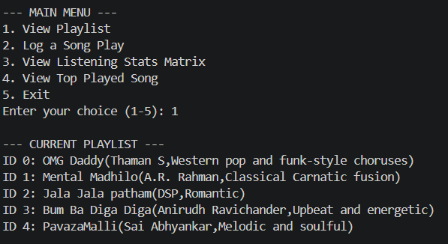

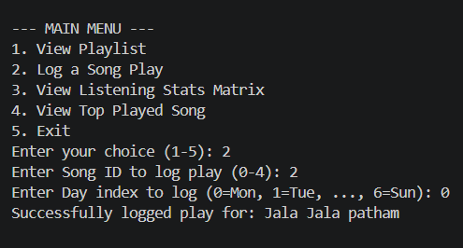

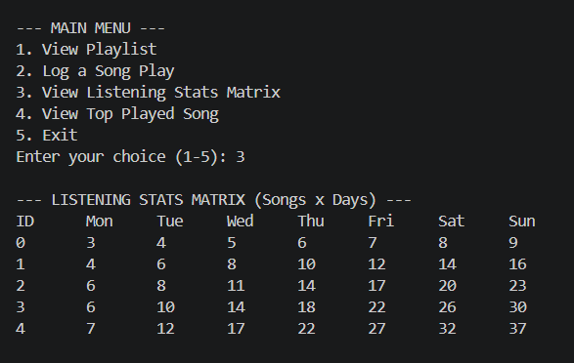

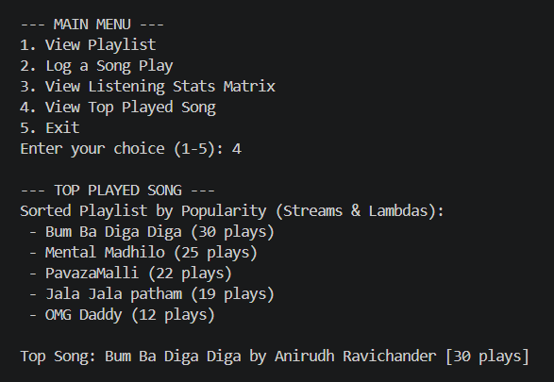

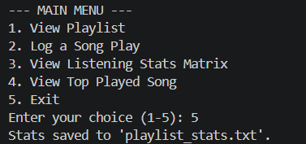

7.Conclusion:
The MusicPlaylistManager project successfully demonstrates the practical implementation of both fundamental and advanced Java programming concepts within a cohesive, console-based application. By effectively integrating Object-Oriented Programming (OOP) principles—such as abstraction, inheritance, encapsulation, and polymorphism—alongside robust data structures like ArrayList and multi-dimensional arrays, the system provides an efficient model for music and playlist tracking.
Furthermore, the incorporation of modern Java features like Streams and Lambdas, coupled with custom exception handling and file I/O operations, ensures that the application is both resilient and functionally rich. It serves as an excellent practical showcase of software modularity, error management, and data persistence.

8.Future Work:
GUI / Web Interface: Upgrade from the console menu to a desktop app (JavaFX) or full-stack web application.
Dynamic Data Structures: Replace the fixed 2D array with flexible collections to support an arbitrary number of songs and days.
Database Integration: Use an actual database (like SQLite or MySQL) instead of text exports for full two-way data persistence.
Multi-User Profiles: Add user authentication to support separate individual accounts and playlists.
Smart Recommendations: Introduce algorithmic song suggestions based on historical playback and matrix trends.

